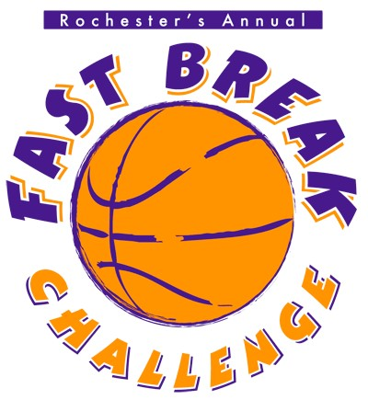
3rd/4th and 5th/6th Grade
Boys & Girls Basketball Tournament

Dates: Thursday, March 5 – Sunday, March 8 (weekday games 4-9pm, weekend games 8am-9pm, Thursday games will only take place based on participation).
Format: Pool play with playoff round for Boys & Girls Divisions. With enough teams, there will be separate “A” and “B” divisions for both Boys and Girls.
Entry Fee: $300. Two officials per game with three games guaranteed. Team awards for 1st & 2nd place teams.
Awards: First and second place teams will receive team plaques. First place team players will receive individual trophies, and second place team players will receive individual medallions.
Games: Two 20-minute running time halves. Clock stops during foul shots and final minute of each half.
Four full time-outs per team per game. Two-minute overtime period with one additional time-out. Pressing allowed only last two minutes of each half.
Fouls: Five fouls per player; bonus on seventh team foul; double bonus on 10th team foul.
Conduct: The head coach of each team will be responsible for the proper conduct of his/her players, assistant coaches, scorekeepers, and fans as well as his/her own behavior while participating in the tournament.
Admission: There will be admissions to enter the games.
All registration forms due by Friday, February 20 (email notification accepted). Space is limited and your spot is not guaranteed until your check and registration form are received. One boys division and one girls division. Maximum of eight teams per division (With enough teams, there will be separate “A” and “B” divisions for both Boys and Girls.). All checks due in hand by the start of the tournament.
Checks made out to: Rochester Boys Basketball Boosters
Mailed to: Rochester Boys Basketball Boosters, c/o Chris Proulx 28 Nottingham Lane, Rochester, NH 03868

Scheduling requests must be received by February 23rd. We will do our best to accommodate all requests.
Final schedule will be emailed to each team contact no later than Friday, Feb 27th.
Please direct any questions to: Chris Proulx rochesterboysbasketball@outlook.com Cell:603-828-4596

Sponsored by
Rochester/SPAULDING BOYS BASKETBALL BOOSTERS
Thursday, March 5 – Sunday, March 8

REGISTRATION FORM

Your spot will be reserved once we receive your registration form and check.
Maximum 8-team boys division & 8-team girls division

Team Name _____________________________________
Coaches Name(s) ________________________________
Coaches Email Address __________________________________ Phone _______________
Checkoff what applies:
Gender: Boys _____ Girls____
3rd Grade Only ____ 4th grade Only ____ 3/4 Combined ____
5th Grade Only ____ 6th Grade Only ____ 5/6 Combined ____

Entry Fee: $300. Two officials per game with three games guaranteed. Team awards for 1st & 2nd place teams.

Admission: There will be admissions to enter the games
All registration forms due by Friday, February 20th, 2025 (email notification accepted/ rochesterboysbasketball@outlook.com)
After registration and prior to the tournament, a link will be provided to the coach’s provided email address. Using this link, you will be able to upload your team roster.

Checks made out to: SHS Boys Basketball Boosters
Mailed to: SHS Boys Basketball Boosters, c/o Chris Proulx 28 Nottingham Lane, Rochester, NH 03868

No double rostering players. A player may only play for one team in the tournament.
No AAU Teams. The tournament is for town travel teams and town all-star teams.
• Please contact Tournament Director Chris Proulx 603-828-4596 with any questions about eligibility.

Full Concession Stand Featuring:
Hot Dogs | Pizza | Popcorn | Candy | Gatorade | Water | Soda | and More!

Rochester Community Center – 150 Wakefield Street, Rochester NH
$300 per Team | 1 Boys Division & 1 Girls Division | Guaranteed 3 Games

