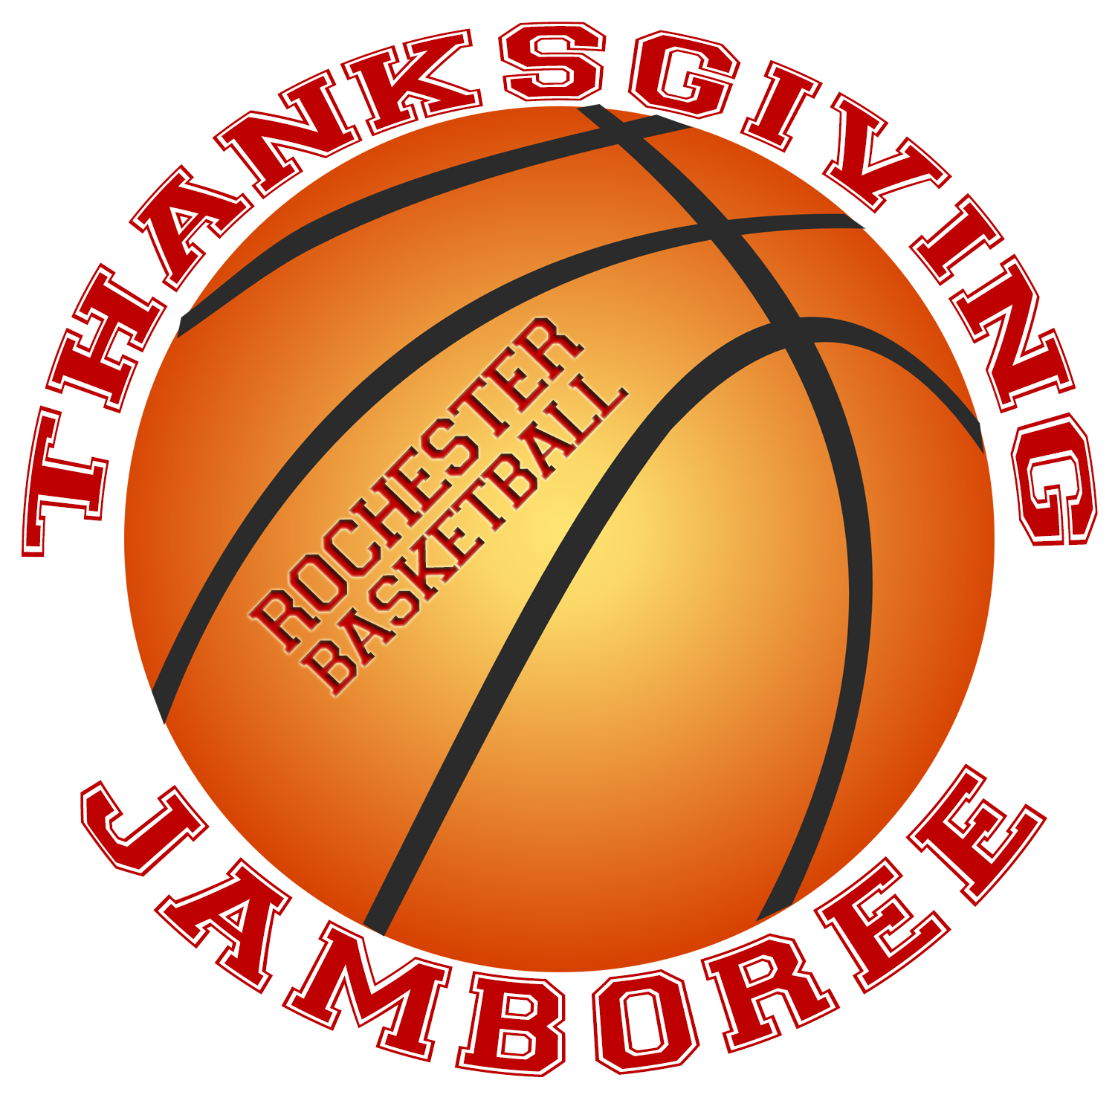

Saturday, November 29th
7th and 8th Grade - Boys and Girls
Rochester Community Center – 150 Wakefield Street, Rochester
Cost: $125 per team
Each team plays three 20-minute games

ROCHESTER BOYS BASKETBALL BOOSTERS
Present
REGISTRATION FORM
Team Name
Team Gender (circle one) Boys Girls
Coach(s) Name
Team Contact’s name, phone # and email

Team Grade (circle one) all 7th grade all 8th Grade both 7th/8th Grade
Comments
Tournament Date: Saturday, November 29th
Admission: $3.00 Adults $1.00 Students/Seniors Kids under 5 – free
Entry Fee: $125 per team. Please use one registration form per team.
All registration forms due by November 14, 2025 (email notification accepted). Space is limited, spot not guaranteed until check and registration are received.

Make check payable to: Rochester Boys Basketball Boosters Club
Mail to: Rochester Boys Basketball Boosters, c/o Christopher Proulx
28 Nottingham Lane Rochester, NH 03868

Please direct any questions to: Chris Proulx – rochesterboysbasketball@outlook.com Cell: 603-828-4596

